Coding Lab Assignment

***By-(Y. KrishnaKaanth Reddy) 321910306039***

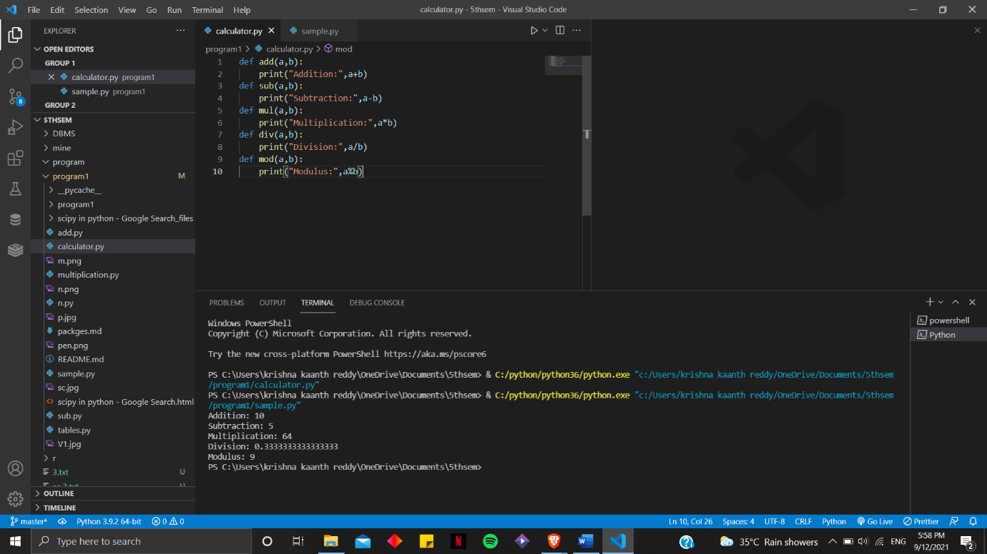

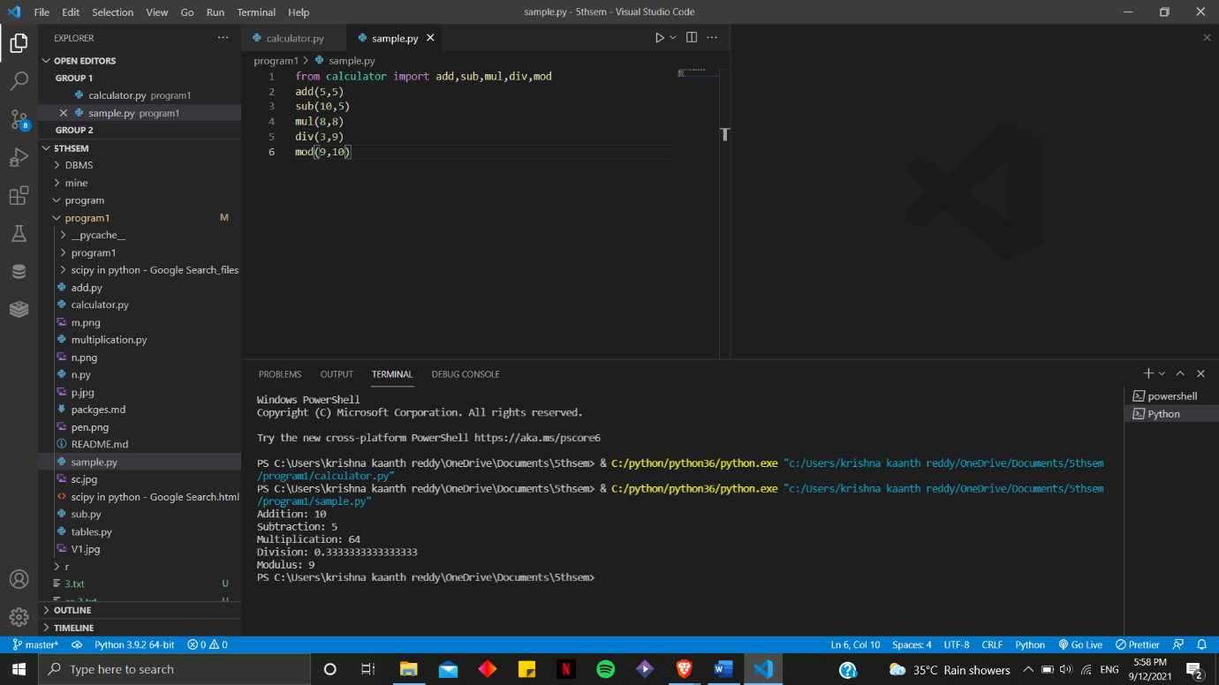

***Github link: https://github.com/krishna0631/program1.git***